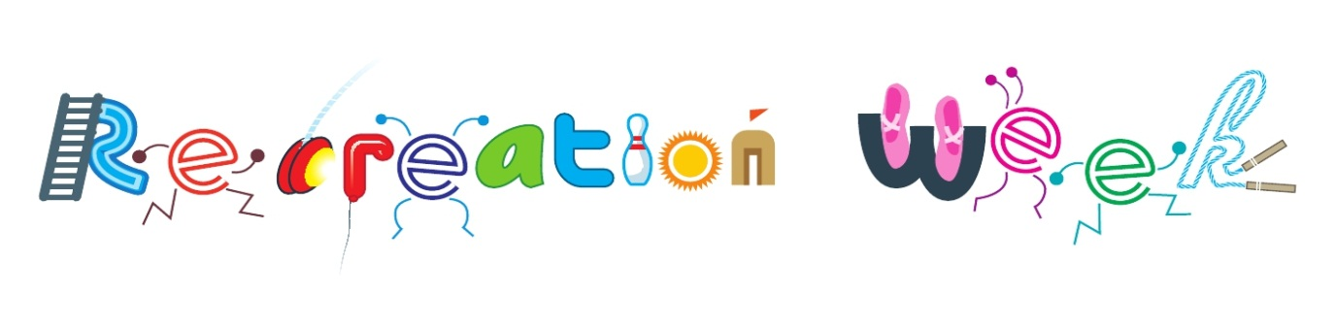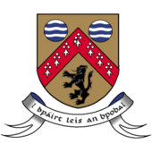

***2017***

The Sport & Leisure Section are delivering Outdoor Adventures Activities for ***National Recreation Week* *2017*** for young people aged 13 – 17.

The aim of National Recreation Week is to highlight the importance of recreation for young people. The theme for this year is ***‘Fun and Active’!***

Places available on **FIRST COME, FIRST SERVED BASIS** & Participants must be available to attend **all 3 days**!

**Max 30 Participants!**

Activities will include 3 days of Outdoor Adventure Activities – which promise to entertain & challenge!

No charge for activities, just a contribution for buses – approx €30(TBC)

Departing Áras an Chontae at 9am sharp each morning!

**Events for National Recreation Week 2017**

Monday 26th June: ***“Slieve Bloom Challenge”***

Wednesday 28th June: ***Kayaking/Canoeing***

Friday 30th June: ***“Active Challenge” and Fun & Games Páirc an Phobail, Portlaoise***

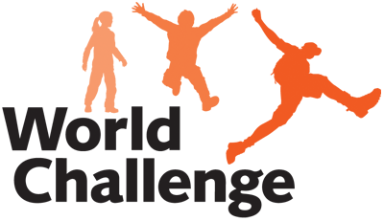

Contact the Sport & Leisure Office ASAP on [*sports@laoiscoco.ie*](mailto:sports@laoiscoco.ie) or call ext *0578664058* and complete & return the attached Consent Form!