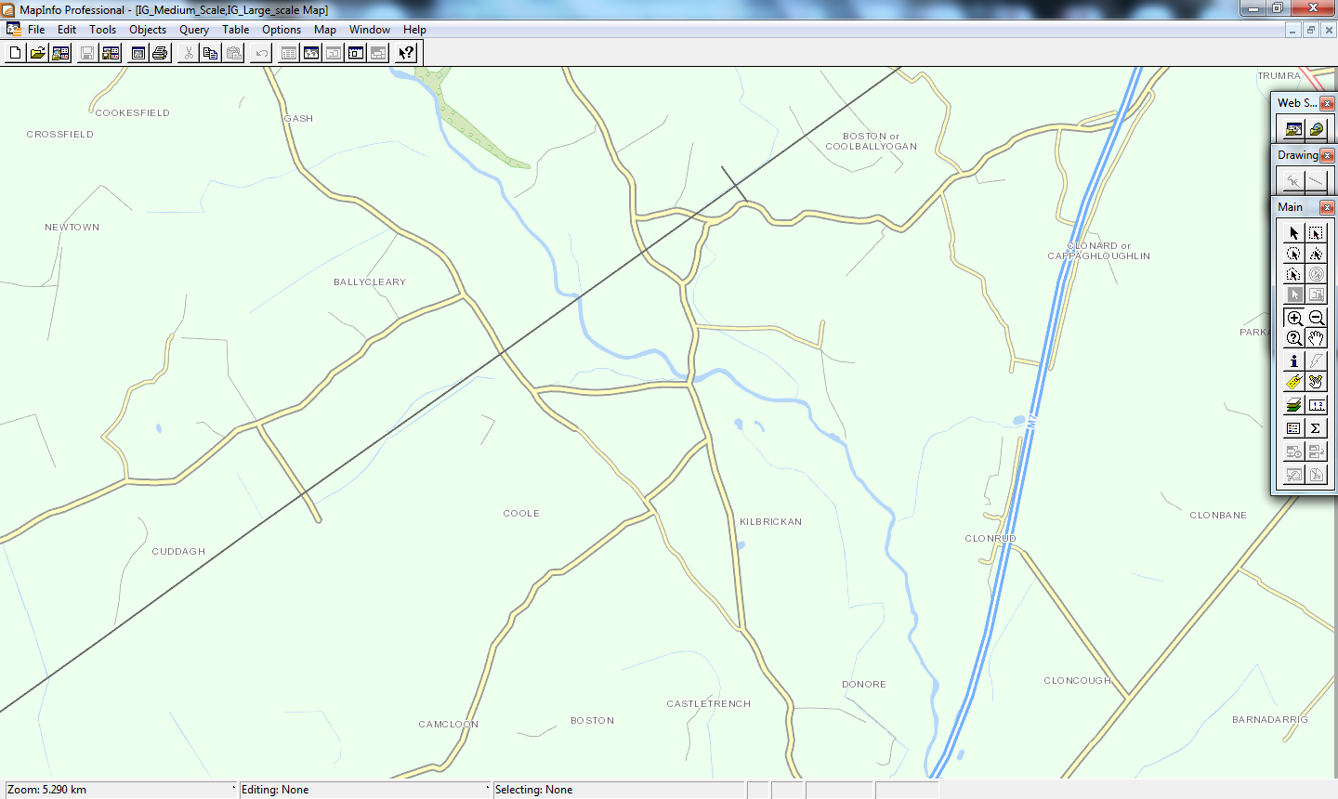

Road closed due to flooding at Jackson’s Bridge Killbricken