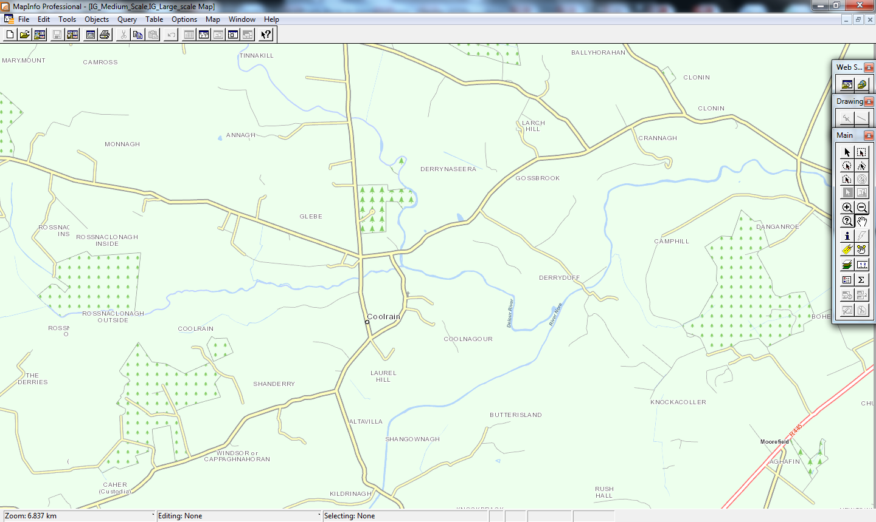

Road closed at these points due to very bad flooding 