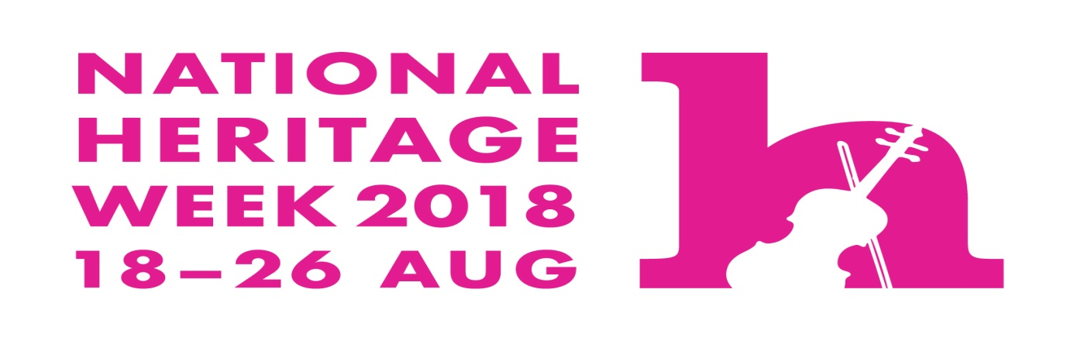
HERITAGE WEEK EVENTS
AT MOUNTRATH LIBRARY
TUESDAY  21ST AUGUST  (2-3PM) | IRISH HISTORY LIVE  WITH MICHAEL MOYLAN  “WOMEN IN IRISH HISTORY” | AGES 6 UPWARDS
WEDNESDAY  22ND AUGUST  (10.30AM -12.30PM) | STRAW CRAFT WORKSHOP FOR CHILDREN  COME SEE STRAW ITEMS & MAKE A GOOD LUCK CHARM TO BRING HOME | AGES  8  UPWARDS TO TEENS  ONLY
BOOKING 057/8756378
FROM 1ST AUGUST

