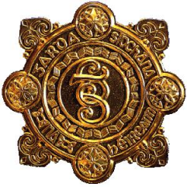
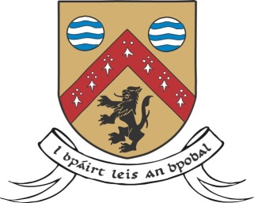
County Laois Joint Policing Committee – Annual Public Meeting
A public meeting of Laois County Joint Policing Committee will be held in the Council Chamber, Áras an Chontae, Portlaoise on:
Monday, 13th November 2017 at 3.30pm
Members of the public are welcome to attend
The function of a Joint Policing Committee is to serve as a forum for consultations, discussions and recommendations on matters affecting the policing of the local authority’s administrative area.
Members of the public have the right to make their views known and ask questions of the Joint Policing Committee. Questions will be accepted by the Joint Policing Committee from any individual member of the public, or collectively from any group/organisation.
Questions in relation to the above, or any other relevant topic, should be submitted in advance in writing to Ms. Georgina Ireland, Administrative Officer, Community Development, Laois County Council, Áras an Chontae, Portlaoise, Co. Laois, by email to dce@laoiscoco.ie or by phone at Tel. (057) 8664206, no later than...
4.30pm on Wednesday, 25th October 2017

It should be noted that in some circumstances it may not be possible to provide information requested.
Name and contact details of those submitting the question should be supplied, but will not necessarily be publicised at the meeting.

