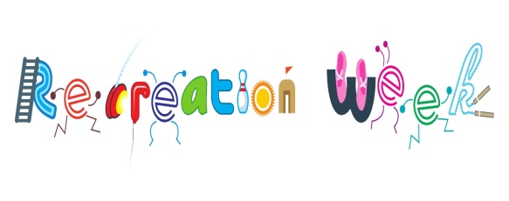

**Consent Form - National Recreation Week 2017**

**Name: ___________________________________________________________________________________________________**

**Address: _________________________________________________________________________________________________**

**Contact Phone Number: ____________________________________________________________________________________**

**Date of Birth: ______________________ Age: _____________________**

**Medical History: ____________________________________________________________________________________________**

**(If Any)**

**Photos/Videos may be taken at National Recreation Events for promotional use, if you have any issues with regard to this matter please contact the Sports & Leisure Section, Laois County Council on (057) 86 64058 or email sports@laoiscoco.ie**

**Please note:**

1. Your child will be supervised at all times
2. It is your responsibility to collect on time
3. In the event of an emergency, we will call the emergency services and contact you also. In the event that we cannot contact you on the above numbers we will request the attendance of the ambulance service and other emergency services deemed necessary and your child will be removed to hospital for treatment.
4. Safeguards - we are committed to the safeguarding of children. You are required to ensure your child is collected at the agreed times, in the event that you do not collect your child and we cannot contact you on the above numbers we may contact An Garda Siochana to report a Child Safeguard concern, and your child may be taken away by the Gardai to ensure their safety.

I __________________________________Parent/Guardian of_______________________________

agree to my child participating in the National Recreation Week 2017 and I acknowledge I am responsible for my child outside of class times. My child will not use a photographic device at this event, and I understand that this important rule is in the interests of child protection

Signature_________________________________________________

Name in Block Capitals______________________________________

**For Official Use Only:**

**Amount Paid:______________ Receipt No:______________**

**For Official Use Only:**

**Amount Paid:______________ Receipt No. _______________**

**For Official Use Only:**

**Amount Paid:______________ Receipt No. _______________**