County Laois Joint Policing Committee Meeting
13th February 2017, 11.30am
at Áras an Chontae, Portlaoise

AGENDA

- Confirmation of Minutes of Annual Public Meeting of Joint Policing Committee held on 19th September 2016
- Matters Arising
- Report from An Garda Síochána
- Laois County Council Report
- JPC Annual Report 2016
- Any Other Business

County Laois Joint Policing Committee Meeting
15th May 2017, 11.30am
at Áras an Chontae, Portlaoise

AGENDA

- Confirmation of Minutes of JPC Meeting held on 13th February 2017
- Matters Arising
- Report from An Garda Síochána
- Laois County Council Report
- JPC Strategy Implementation Plan 2017 – Update on actions
- Any Other Business

County Laois Joint Policing Committee Meeting
18th September 2017, 2.30pm
at Áras an Chontae, Portlaoise

AGENDA

- Confirmation of Minutes of JPC Meeting held on 15th May 2017
- Matters Arising
- Correspondence
- Presentation by Midland Regional Drug & Alcohol Task Force
- Report from An Garda Síochána
- Laois County Council Report
- Approval of Community CCTV Schemes
- JPC Strategy Implementation Plan 2017 – Update on actions
- Any Other Business

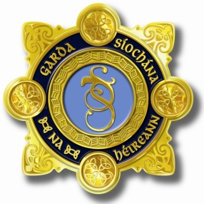
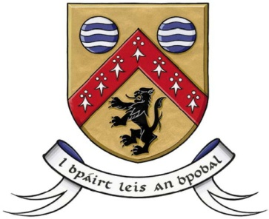

Laois County Joint Policing Committee Meeting
Áras an Chontae, Portlaoise
13th November 2017, at 3.30pm

AGENDA

- Confirmation of Minutes of Joint Policing Committee Meeting held on 18th September, 2017 (copy attached)
- Matters Arising
- Report from An Garda Síochána
- Laois County Council Report
- Questions submitted by members of the public
- Any Other Business

