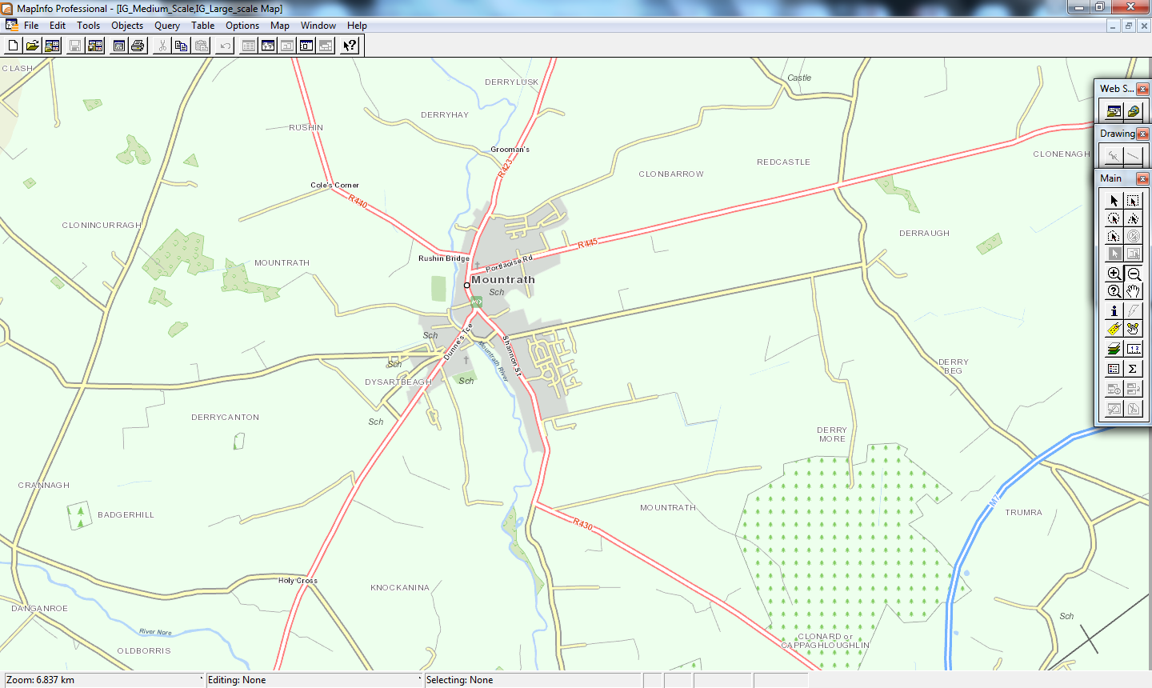

Road closures in Mountrath

Link road and entrance into GAA ground 