LAOIS PPN REGISTRATION FORM 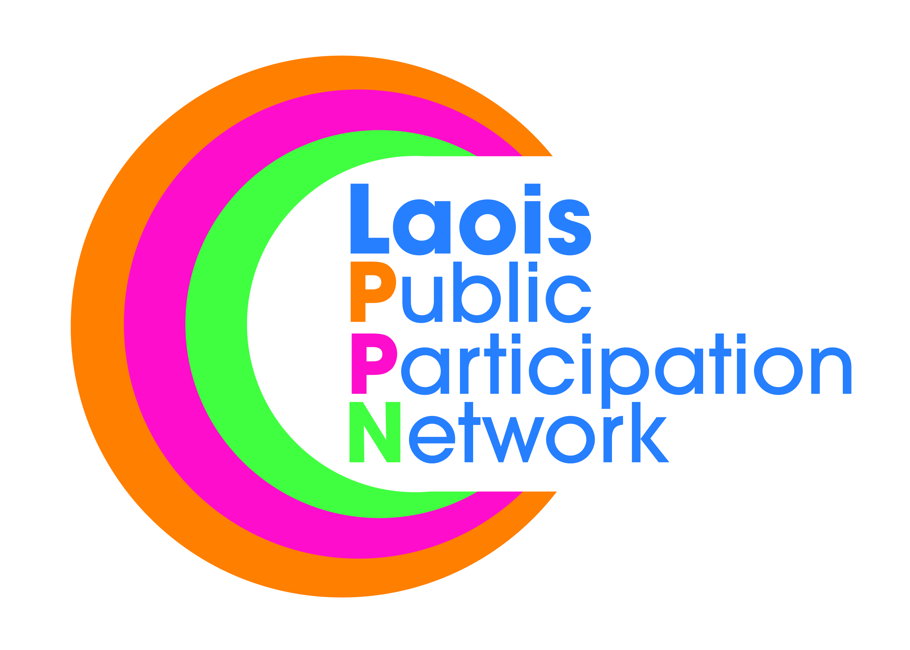
SECTION A - Your Group / Organisation

Name of Organisation/Group:
Aims / Objectives of your organisation/group:
Where does your group hold meetings/operate in?
Please tick the Municipal District your group is based in: | Borris-in-Ossory/Mountmellick
 | Portlaoise
 | Graiguecullen/Portarlington
Email address for your group:
Please classify your group/organisation as mainly involved in ONE of the following areas (tick one box only) | Social Inclusion
 | Community & Voluntary
 | Environmental
Under the heading you ticked above, please circle what you consider to be your group’s main activities: | Social Inclusion | Community & Voluntary | Environmental
 | Disability Organisation | Residents’ Association | Transport
 | Active Elderly | Culture, Arts, Heritage | Environmental Awareness/protection
 | Children/Youth Services or Supports | Sports / Leisure | Species Care/Conservation
 | Parenting Alone | Community  Council/Centre/Hall /Association | Water/Energy Conservation
 | Health related group | Social / get together | Sustainable development
 | Ethnic minority support | Festival / Event based
 | Social Justice /  Social Equality | Tidy Towns

Please tick one or more Special Interest Groups (SIG) your group would like to be associated with.  (Please note you need to be registered with a SIG in order to be nominated for or vote for a Representative position associated with the SIG) | Economic Development, Enterprise & Planning Strategic Policy Committee
 | Transportation, Environment & Emergency Services Strategic Policy Committee
 | Community, Social, Cultural & Heritage Strategic Policy Committee
 | Housing Policy Strategic Policy Committee
 | Local Development
 | Tourism
 | Tidy Towns
 | Policing
 | Sport
 | Youth
 | Active Retirement/Elderly

SECTION B – Group Details
Date your group/organisation was set up: | No. Of Members
Does your group have:
- Regular meetings? | Yes No
- Written minutes? | Yes No
- Written constitution / Statement of Aims & Objectives? | Yes No
- Bank / Credit Union /other Account? | Yes No
- Minutes of your last AGM recording election of officers / committee? | Yes No
Date of last AGM held?

Where there is less than 6 members in your group/organisation, please give their names: | 1.
 | 2.
 | 3.
 | 4.
 | 5.
 | 6.
*As proof of your group’s existence, please provide ONE of the following:  ( Failure to provide one of these documents will deem the group/organisation ineligible for membership and voting on the PPN) | - Minutes of your last AGM or first meeting held  - Proof of a bank account  - Tax clearance certificate

SECTION D – Contact Details
PPN REPRESENTATIVE (i.e., the person who will attend meetings on behalf of your organisation)
Name

Address

Telephone (Mobile if preferable)

EMAIL

ALTERNATE CONTACT
Name

Address

Telephone (Mobile if preferable)

EMAIL

SECTION E – DATA PROTECTION
Would you like to receive Community/Voluntary Information / local updates? | Yes No
Do you agree that your information is maintained on Laois PPN’s Register of Community and Voluntary Groups in accordance with section 12 B of the Local Government Act 2001 | Yes No
Do you grant permission for the contact details of your group to be shared with other PPN members? | Yes No

Signature on behalf of your group/organisation:
Date:
Please return this form to:
Laois Public Participation Network, JFL Avenue, Lyster Square, Portlaoise, Co. Laois
Email: ppn@laoiscoco.ie

www.laoisppn.ie

OFFICE USE ONLY
Municipal District | BinO/MM |  | Portlaoise | GC/Port
College/Pillar | C&V |  | S.I. | ENV
Date of Registration: |  | Date Stamp
Approved by: |  | Processed by:

